**Hands-on Workshop: Deploy a Java Microservices on K8s / OpenShift on IBM Cloud**

Basics - Kubernetes is engine, openshift is car. K8s is role based access control. When installed with openshift, u have single sign on feature available. Openshift is tool for developers and adminstrators. Openshift can run on private , public clouds. ( incl. ibm cloud)

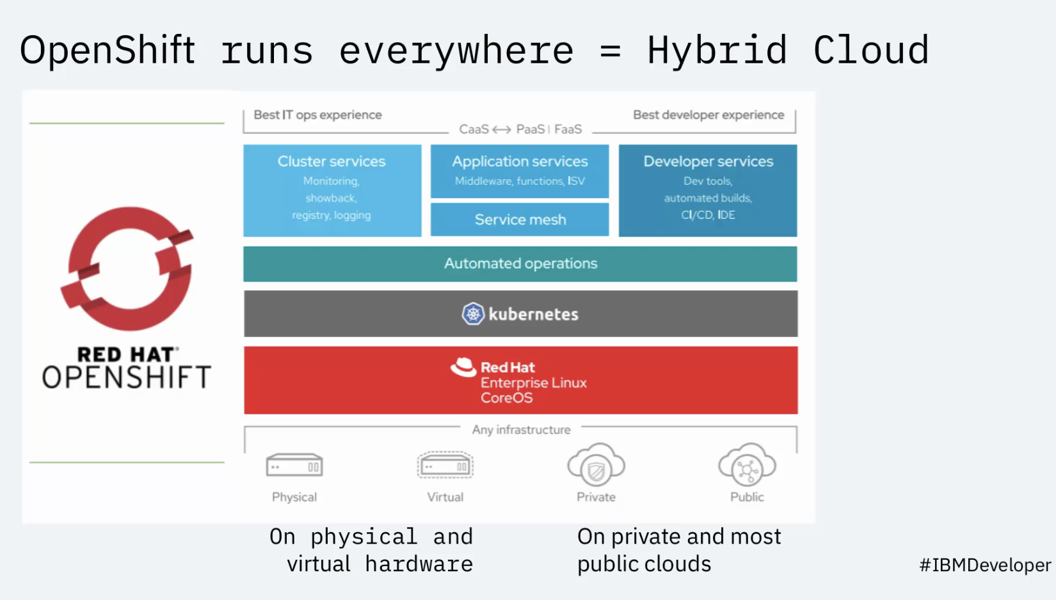

Lab start

<https://ibm.github.io/openshift-on-ibm-cloud-workshops/>

Pre-requisites - <https://ibm.github.io/openshift-on-ibm-cloud-workshops/1-prereqs.html>

1. IBM cloud account

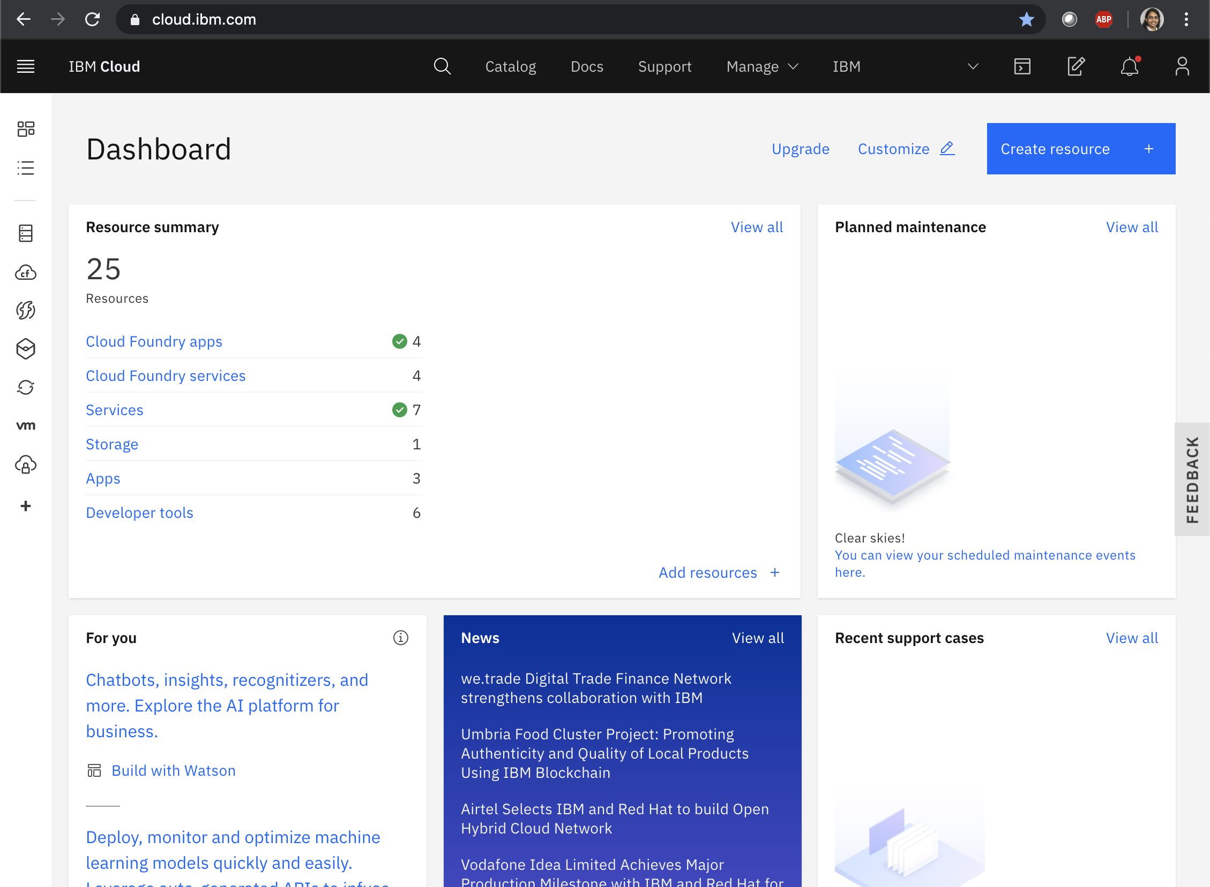

1. Use preconfugured Red Hat OpenShift Cluster for this lab course <https://cloud.ibm.com/kubernetes/catalog/about?platformType=openshift>

## The pre-configured clusters are shown below. Click on one

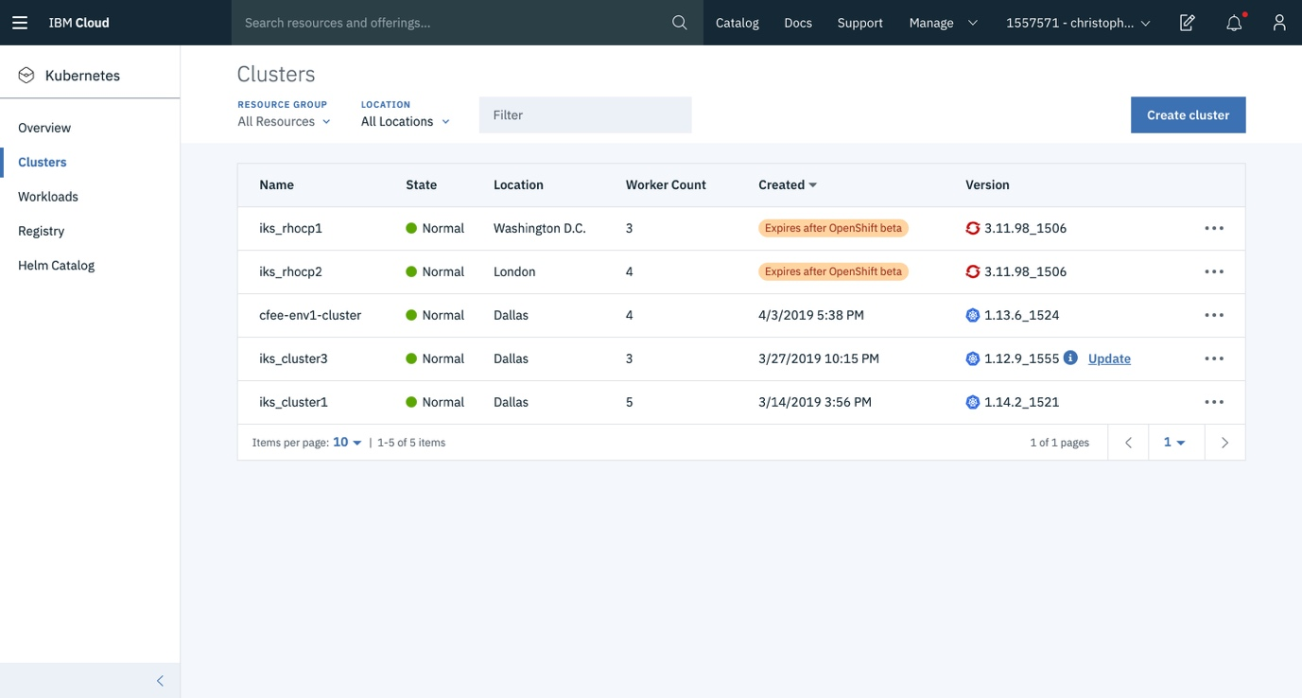

1. Click on cluster and access the below openshit console

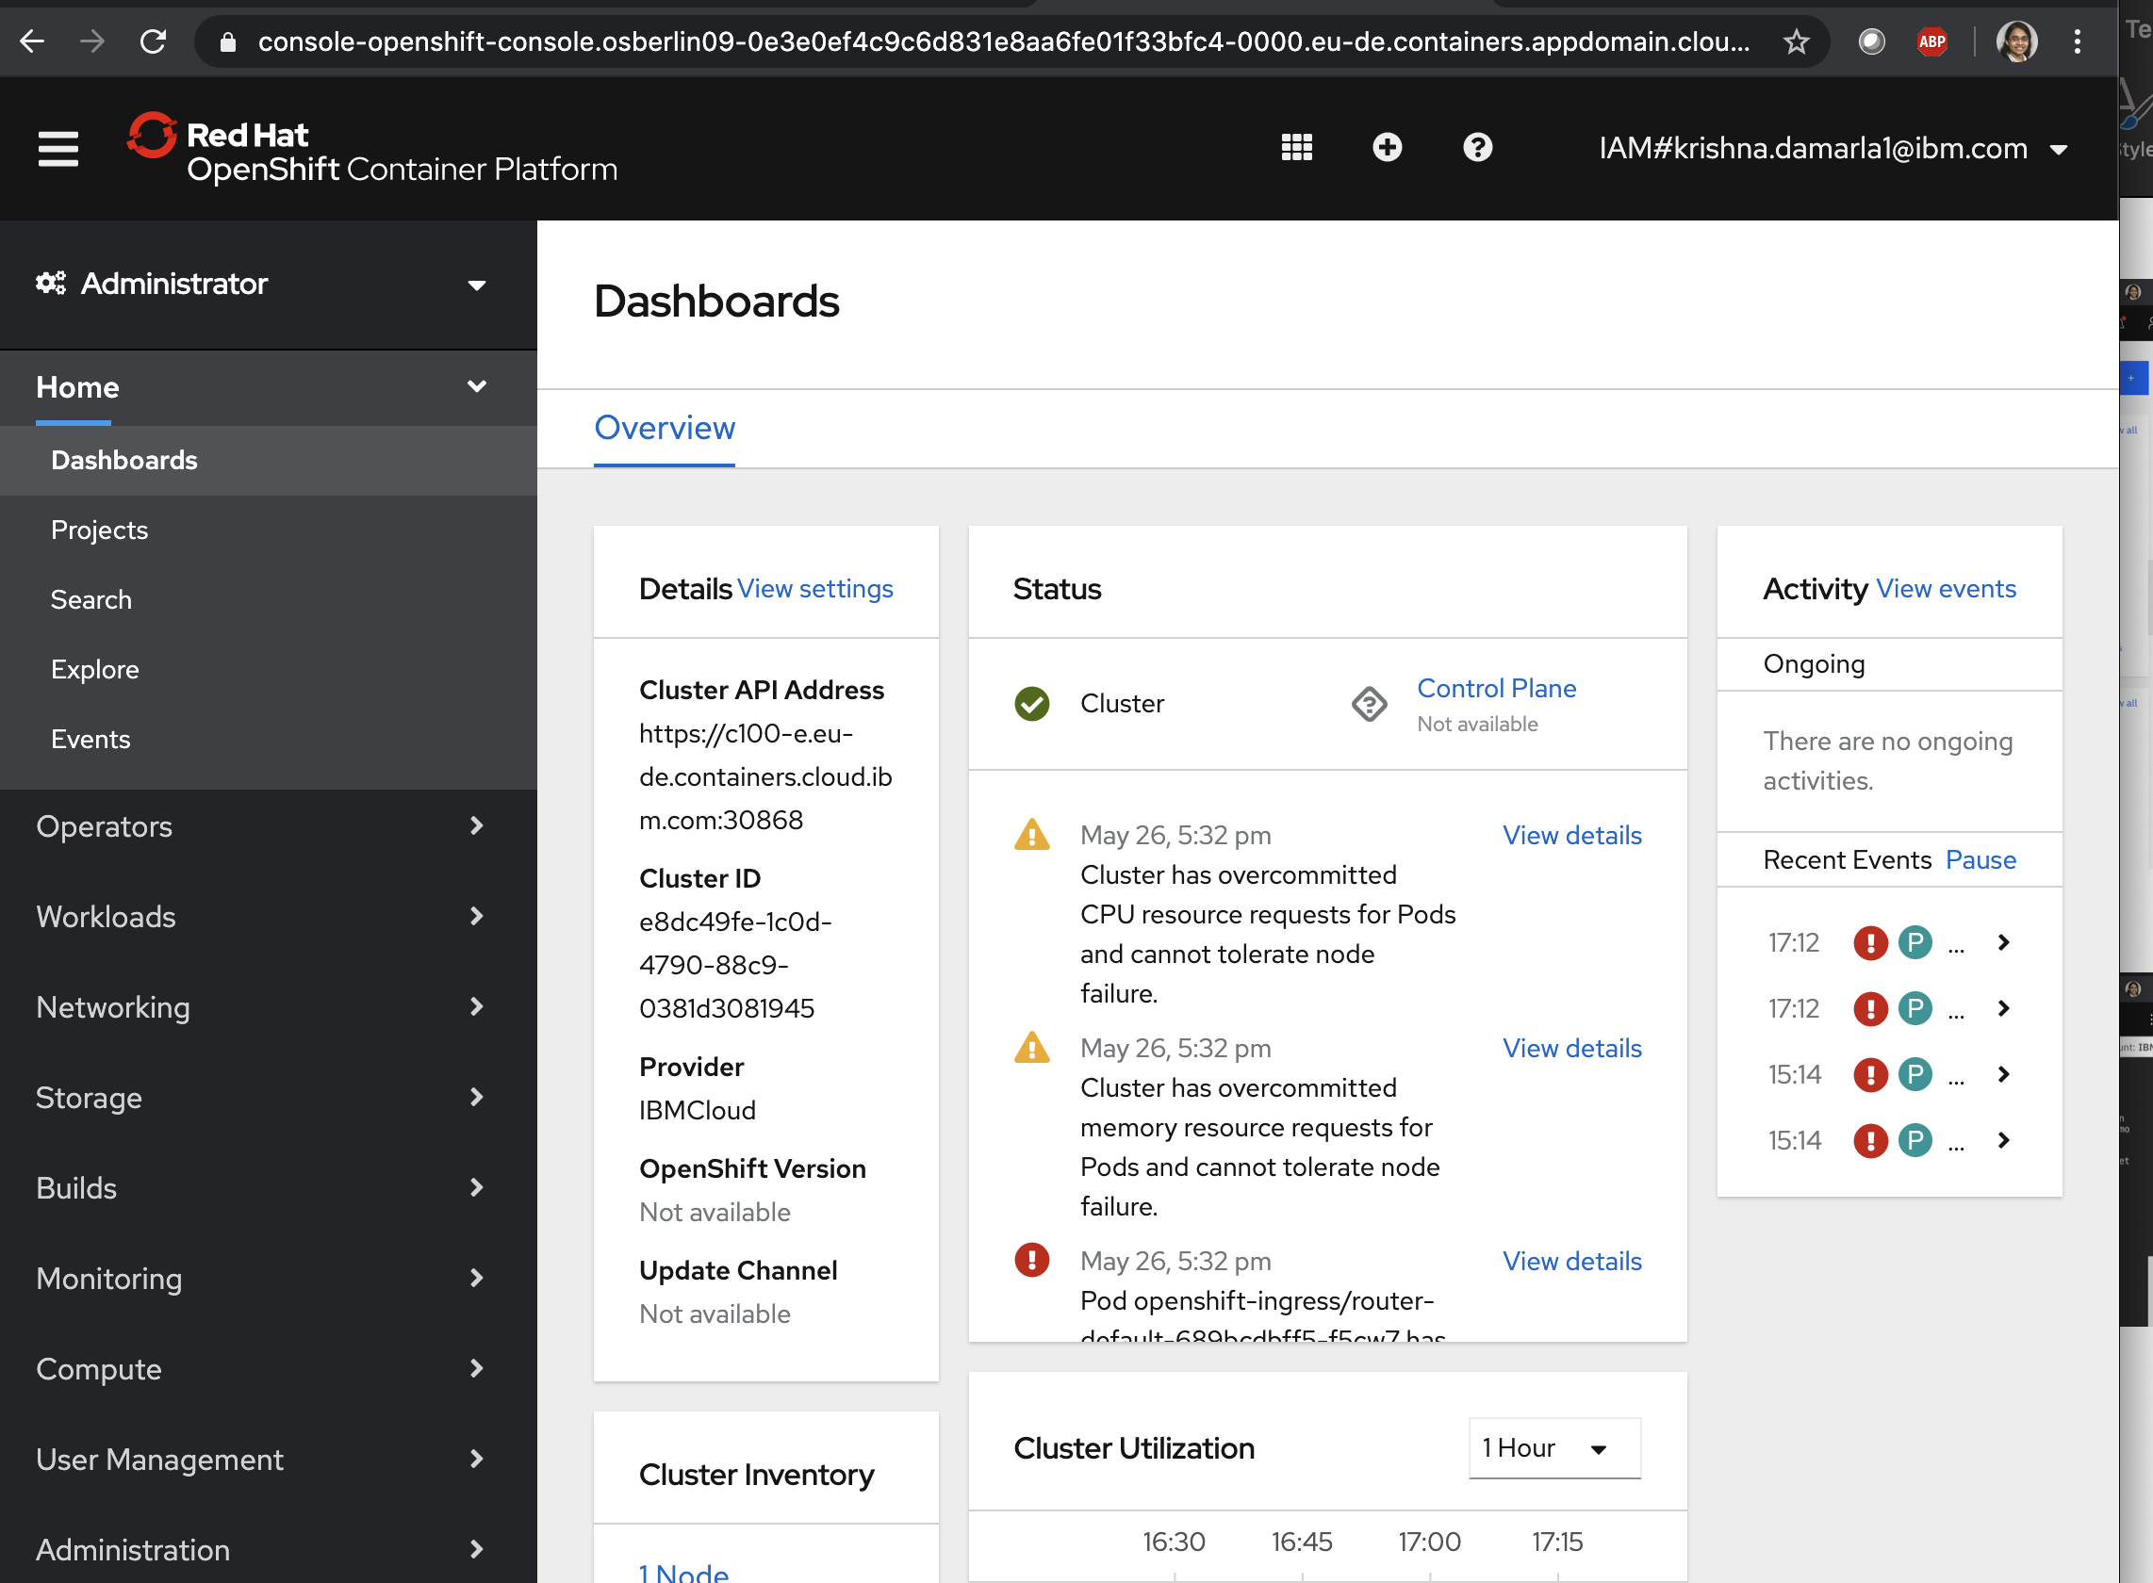

1. Access the Cloud shell from step 1 cloud.ibm.com UI (Click on left to edit pencil to open below shell)

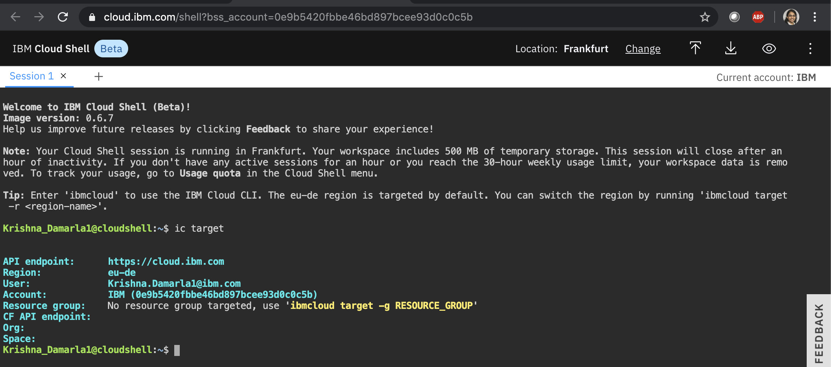

**Lab 4 – Deploying to openshift**

<https://ibm.github.io/openshift-on-ibm-cloud-workshops/1-prereqs.html>

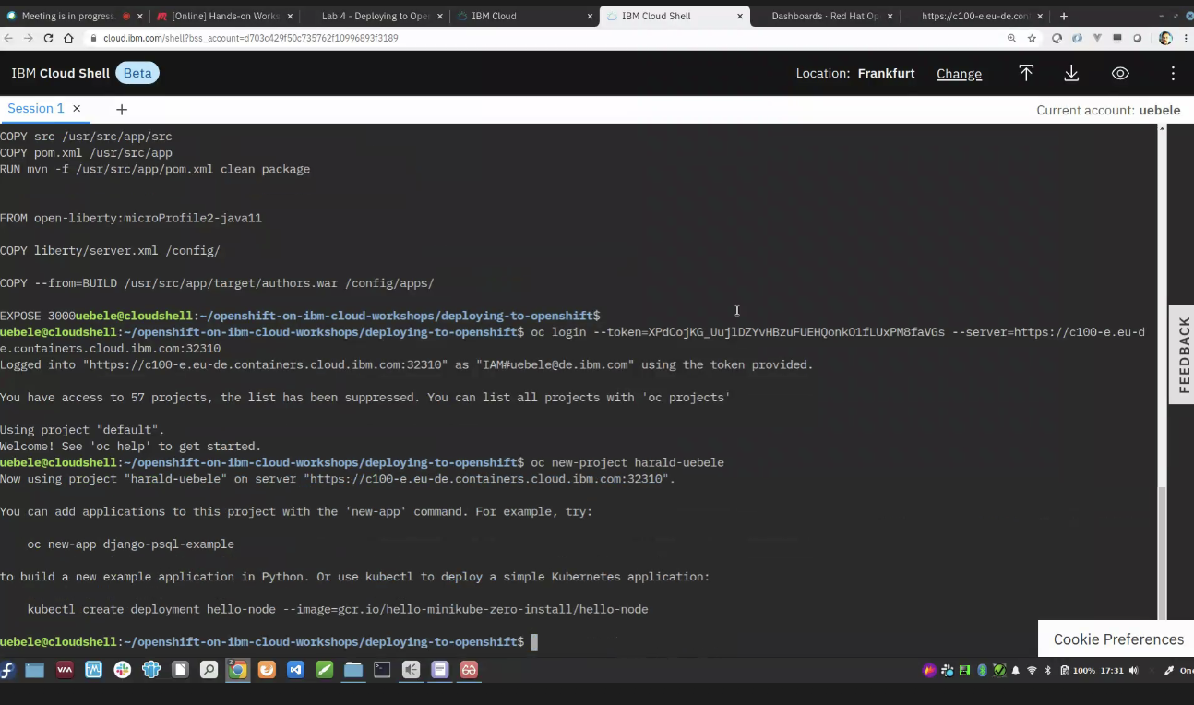

oc project

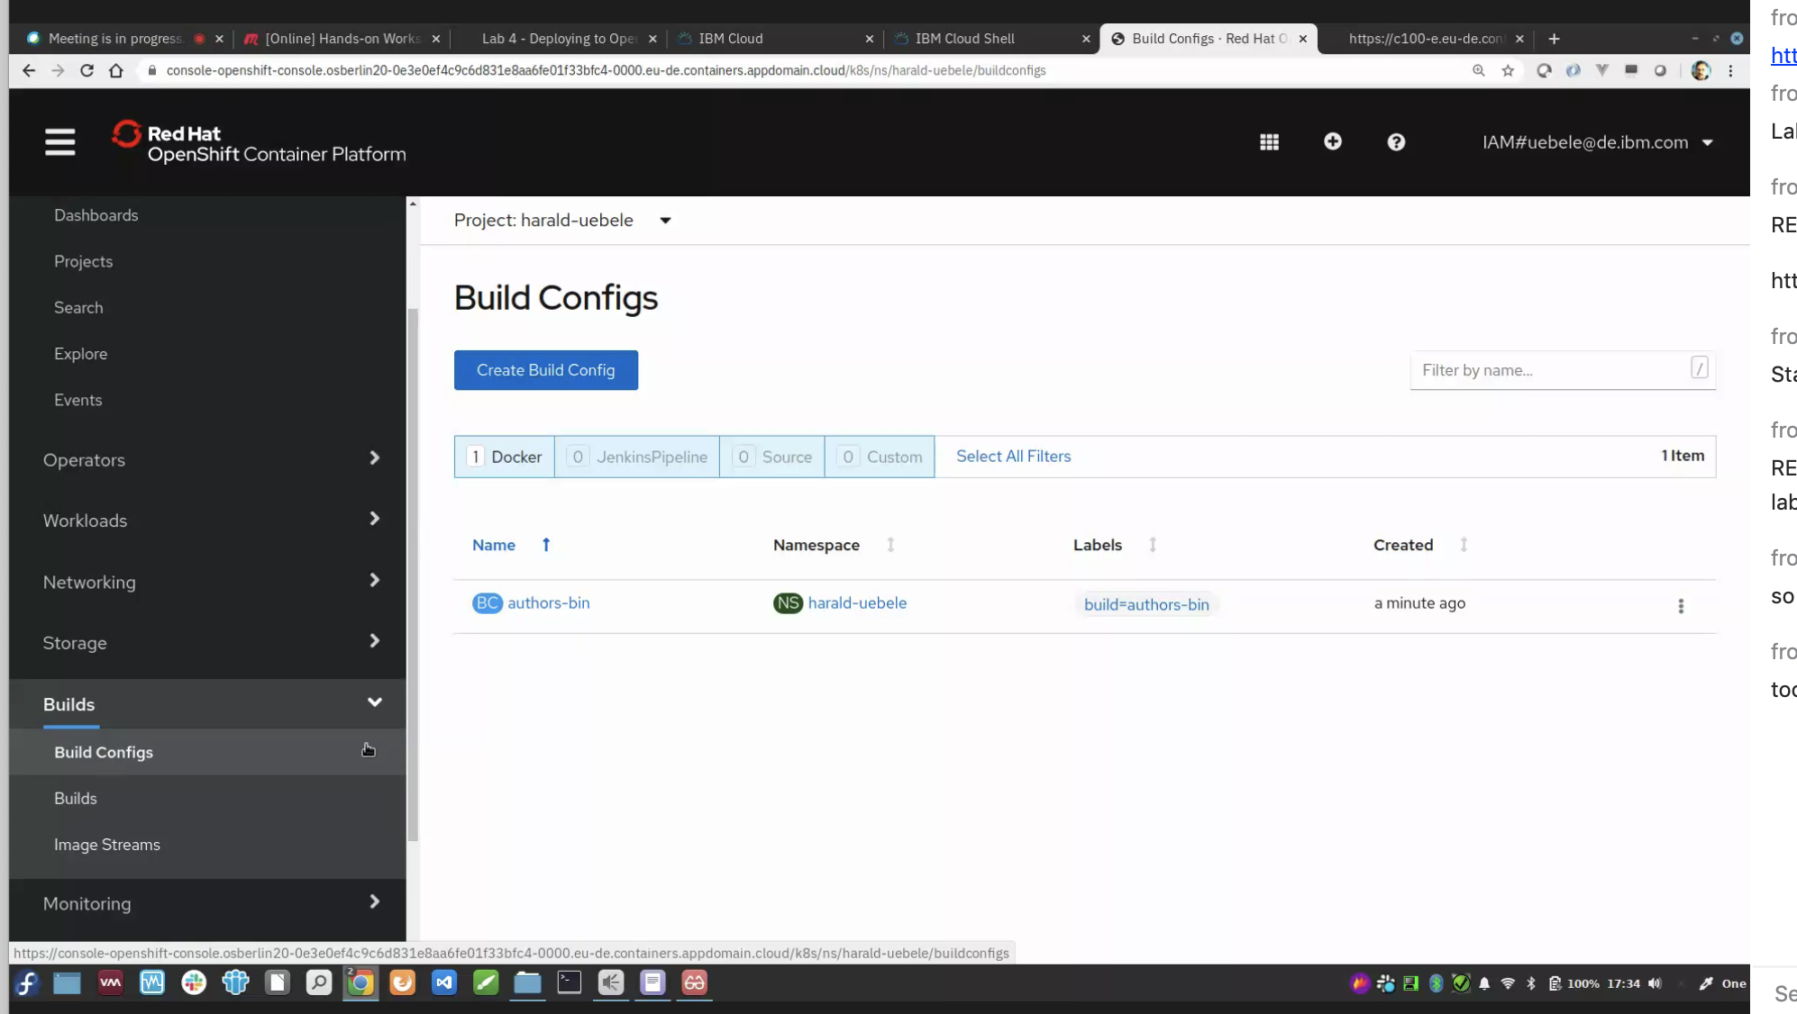

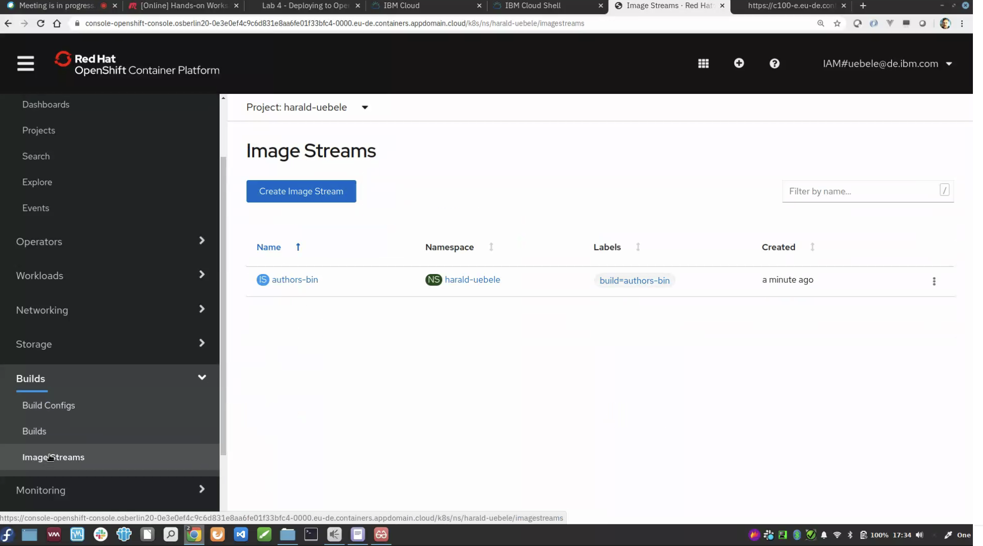

Build

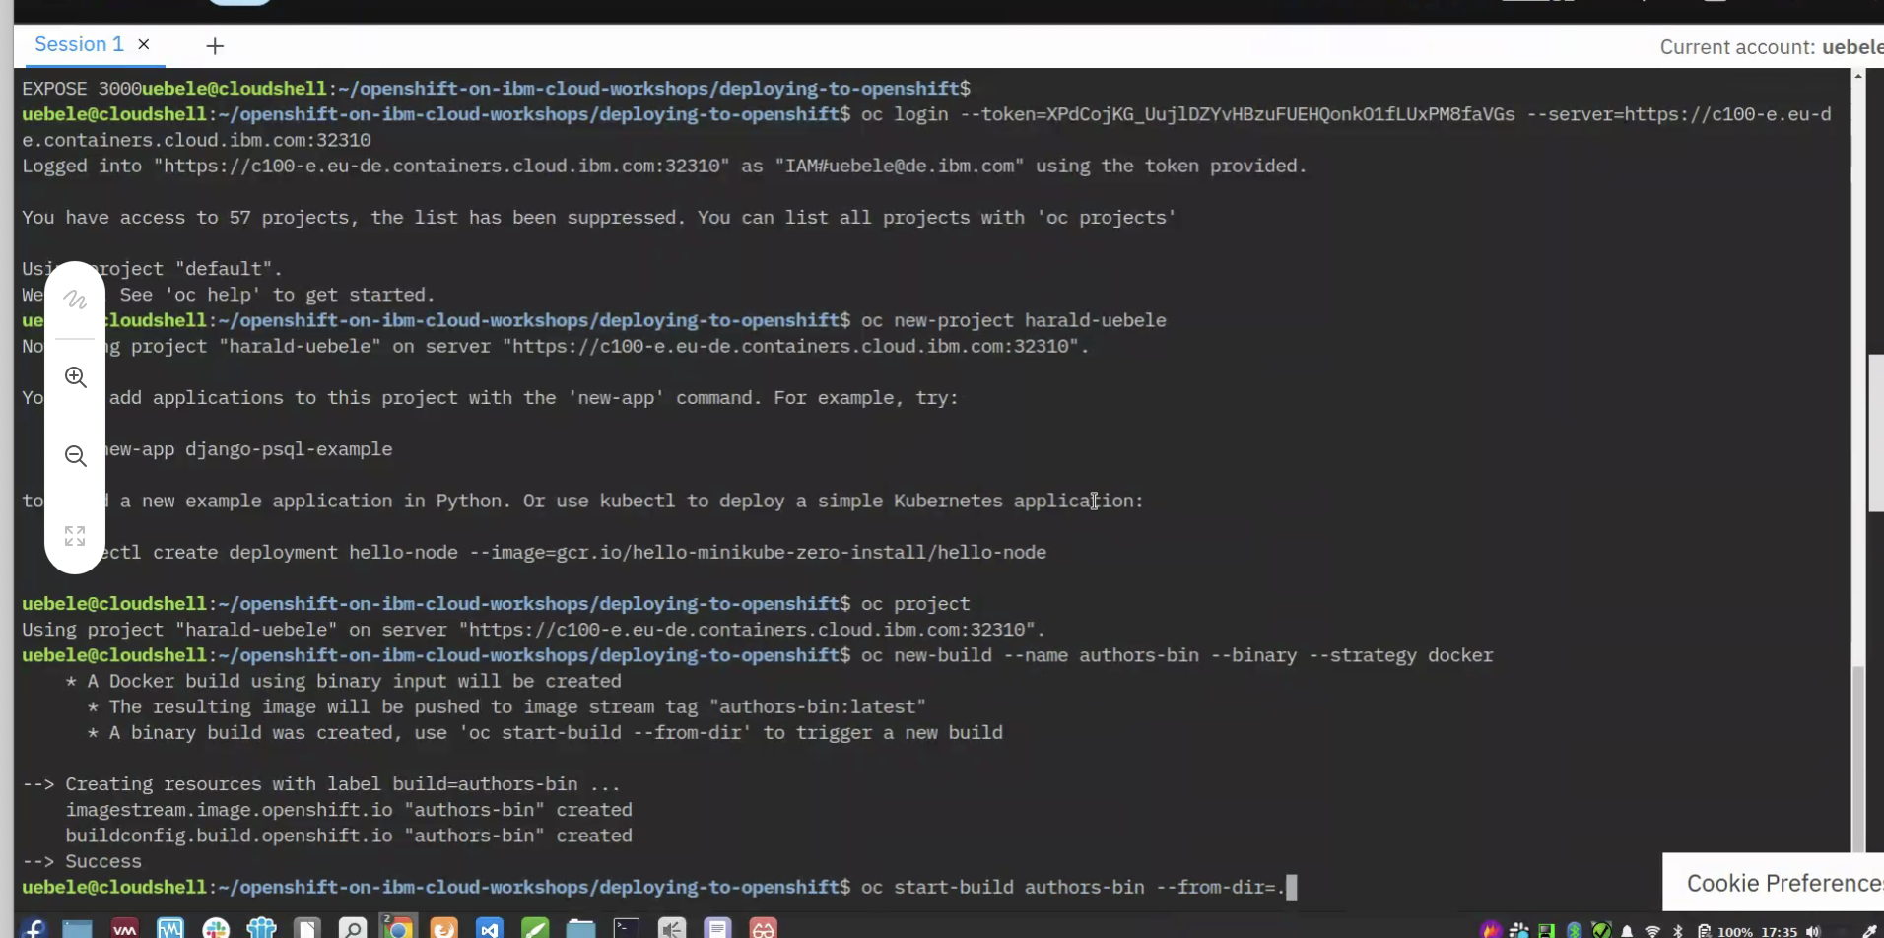

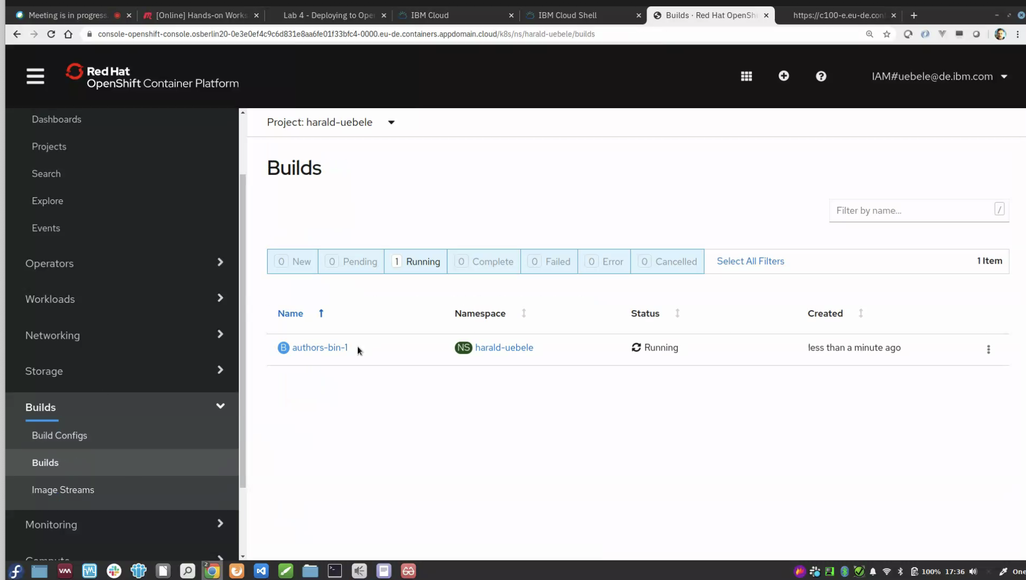

Push mvn image and openliberty image

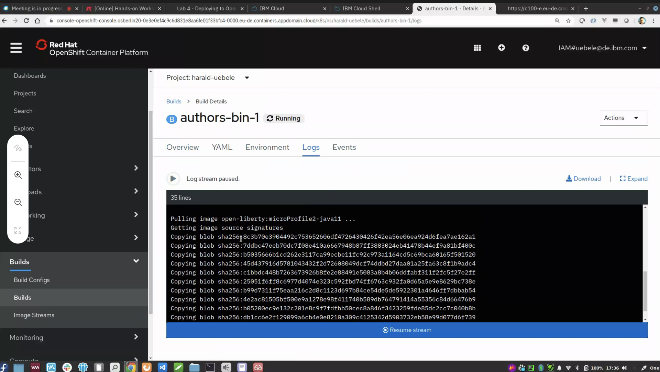

First stage, maven build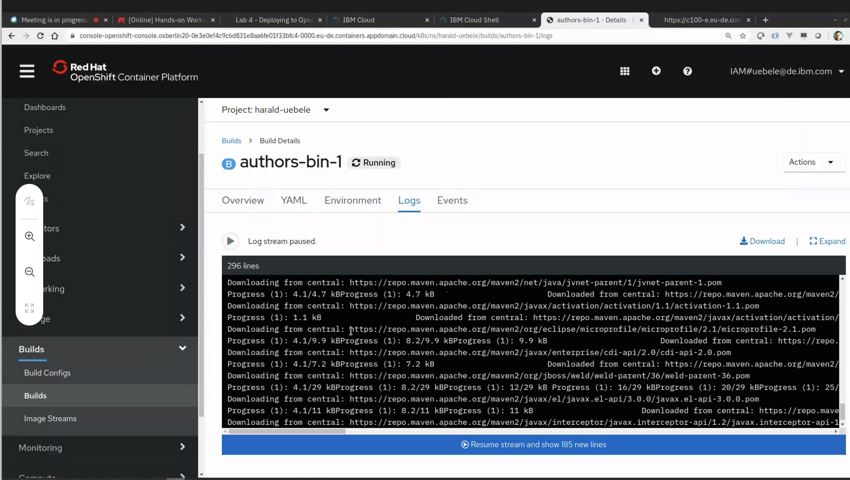

Pushing image back to repository

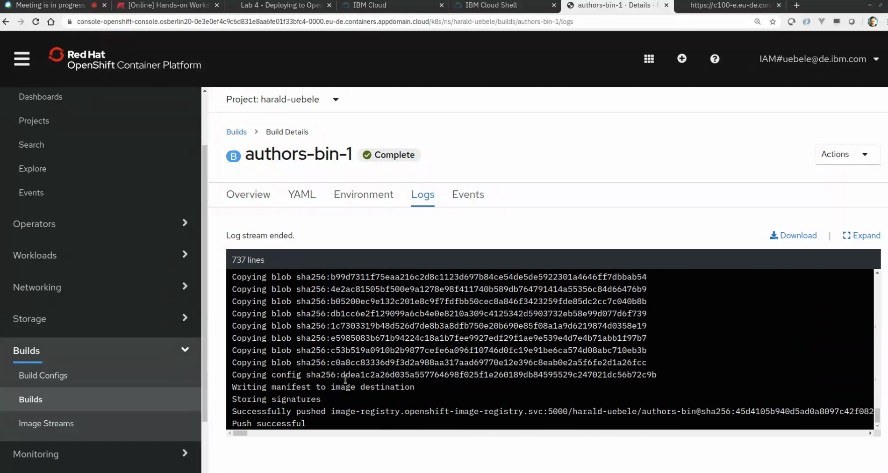

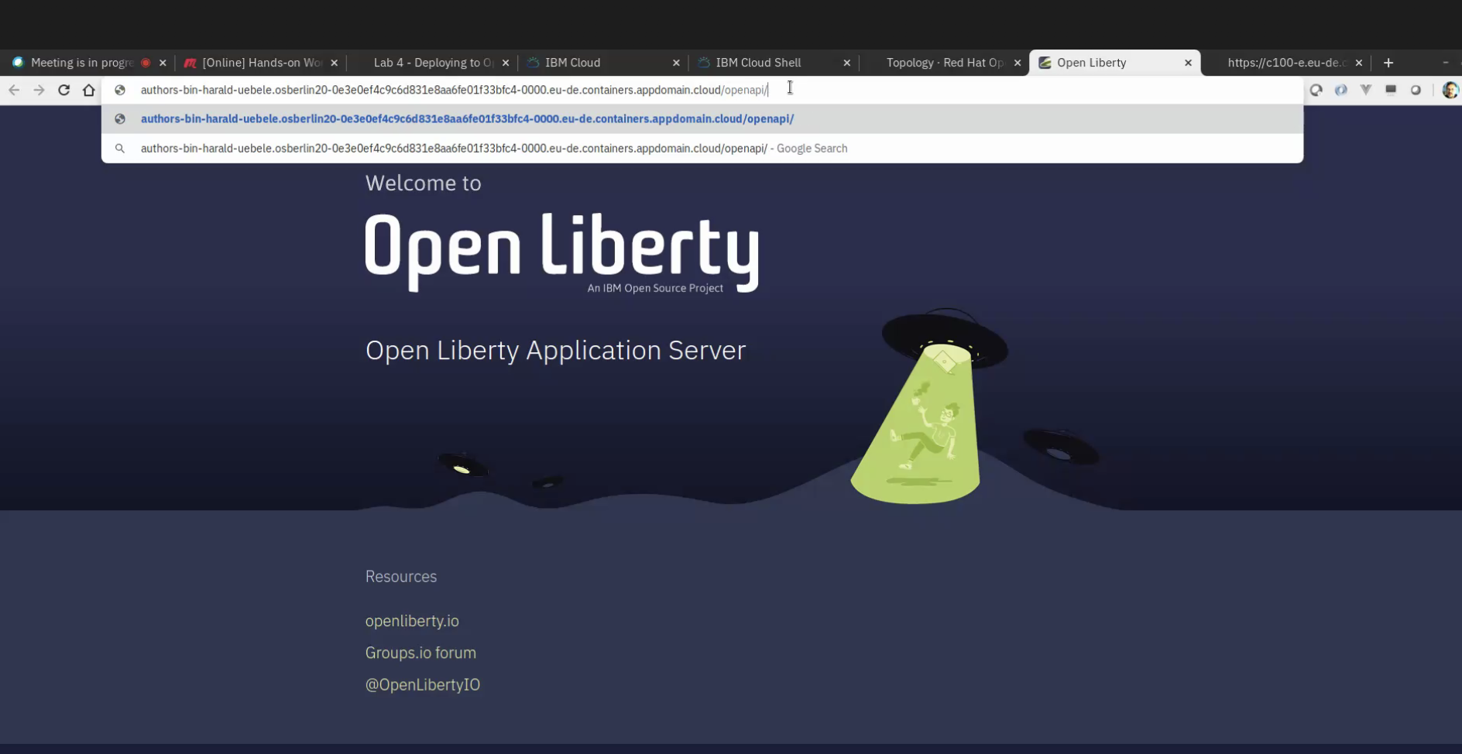

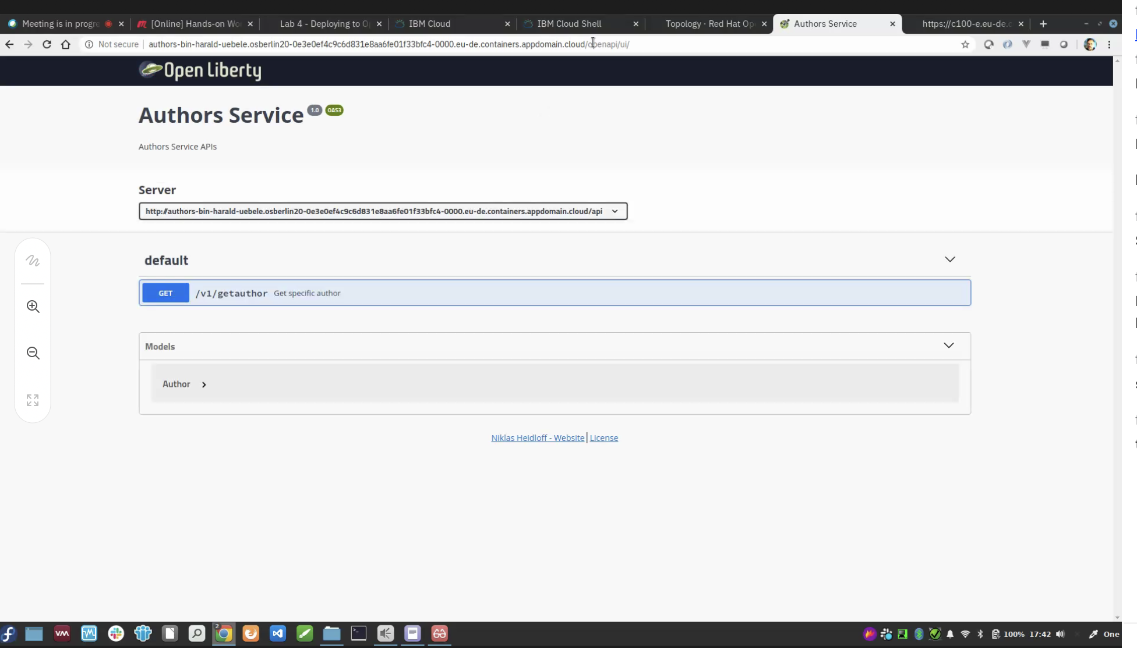

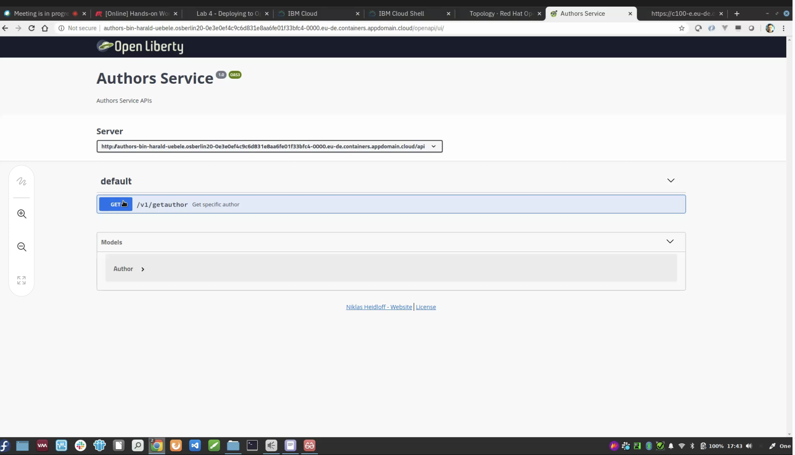

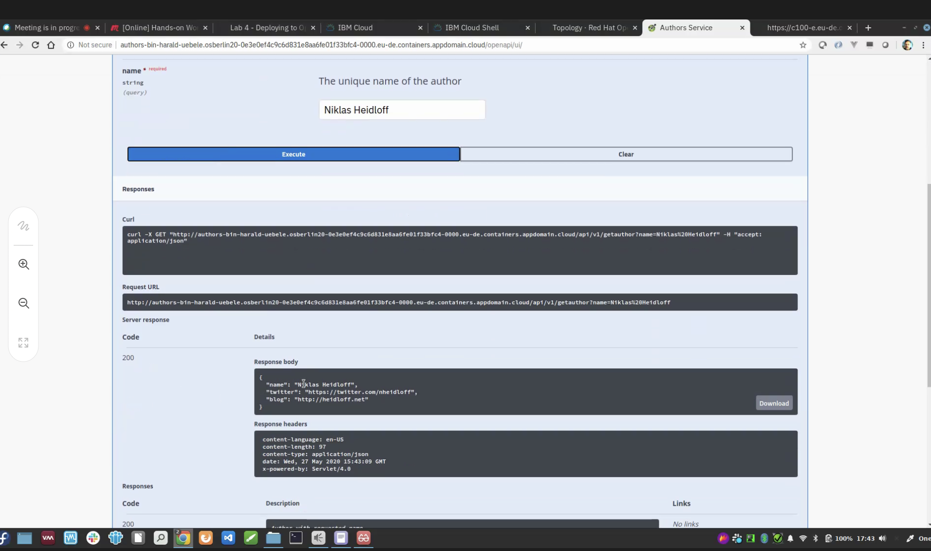

**Lab 6 - Deploy existing image and push to dockerhub**

<https://ibm.github.io/openshift-on-ibm-cloud-workshops/6-existing-image.html>

Add link of image …openshift will get that image from dockerhub

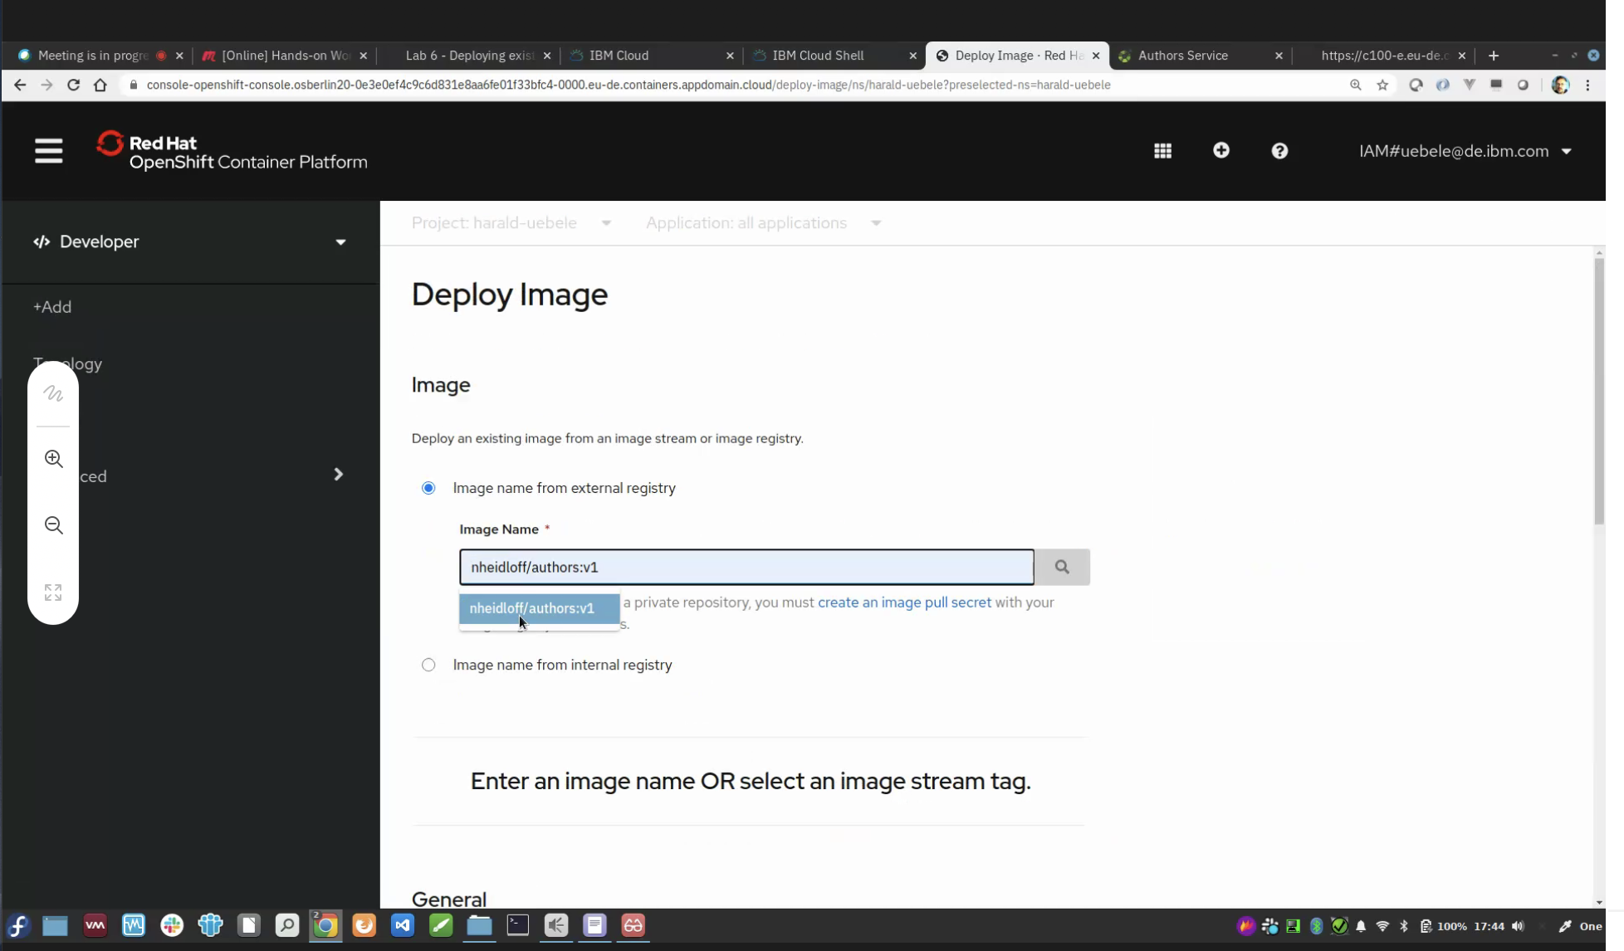

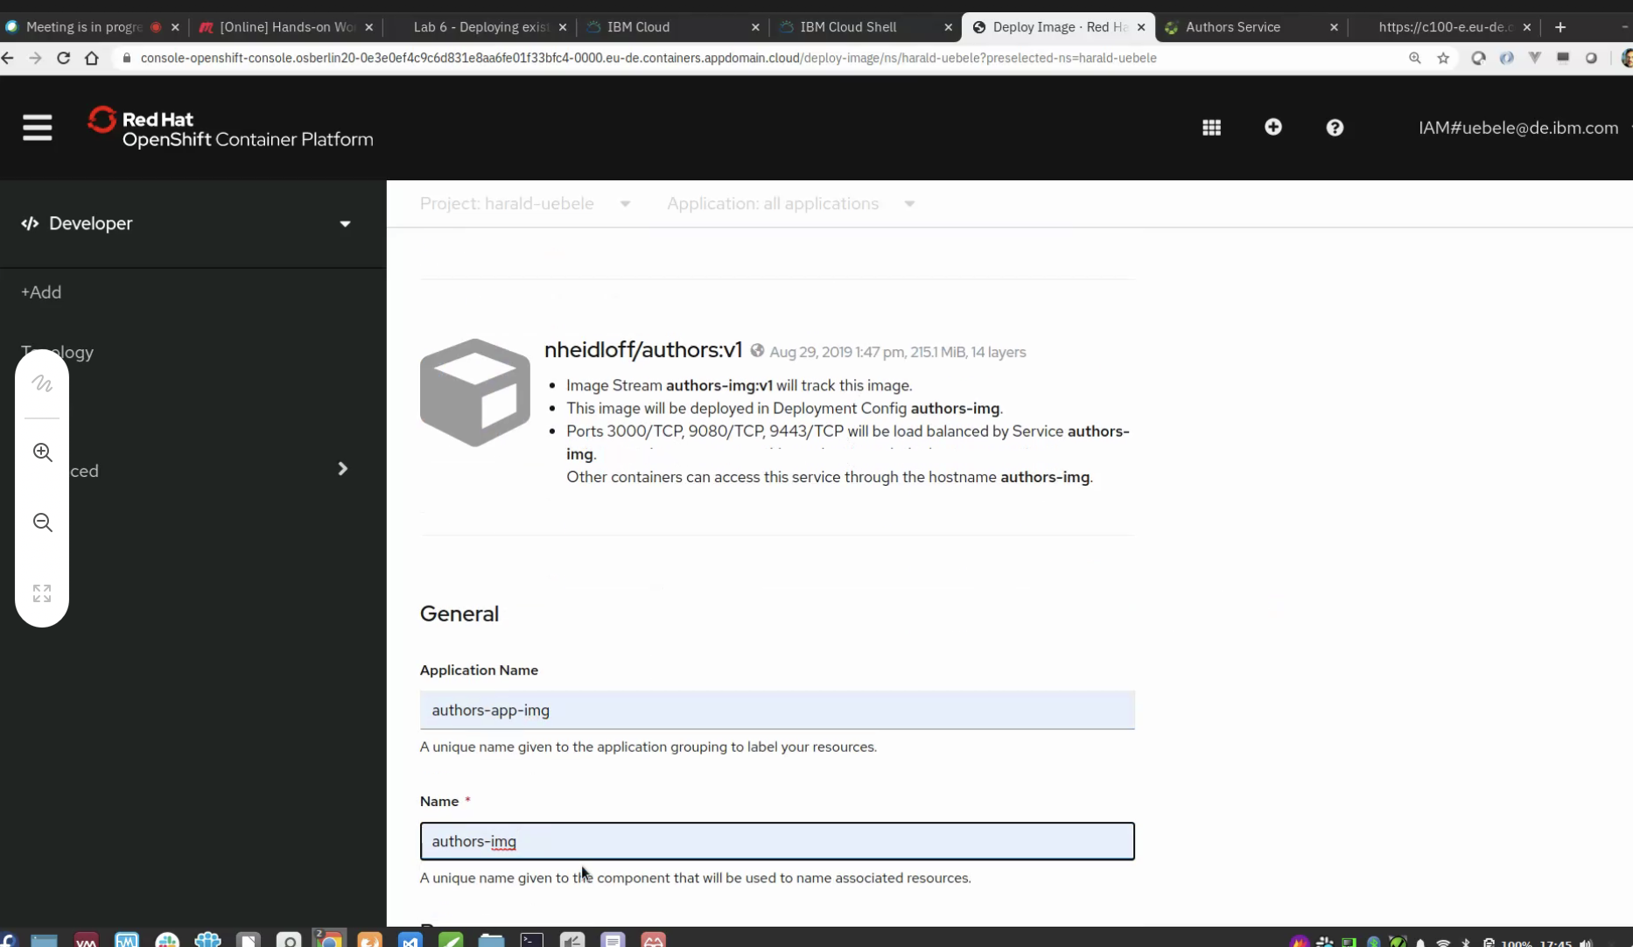

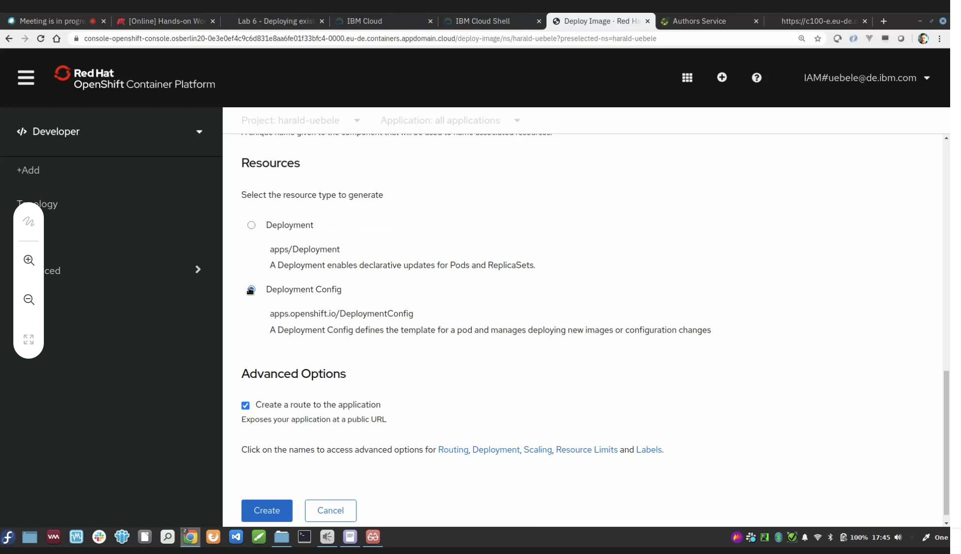

After clicking on create, see logs as shiwn below

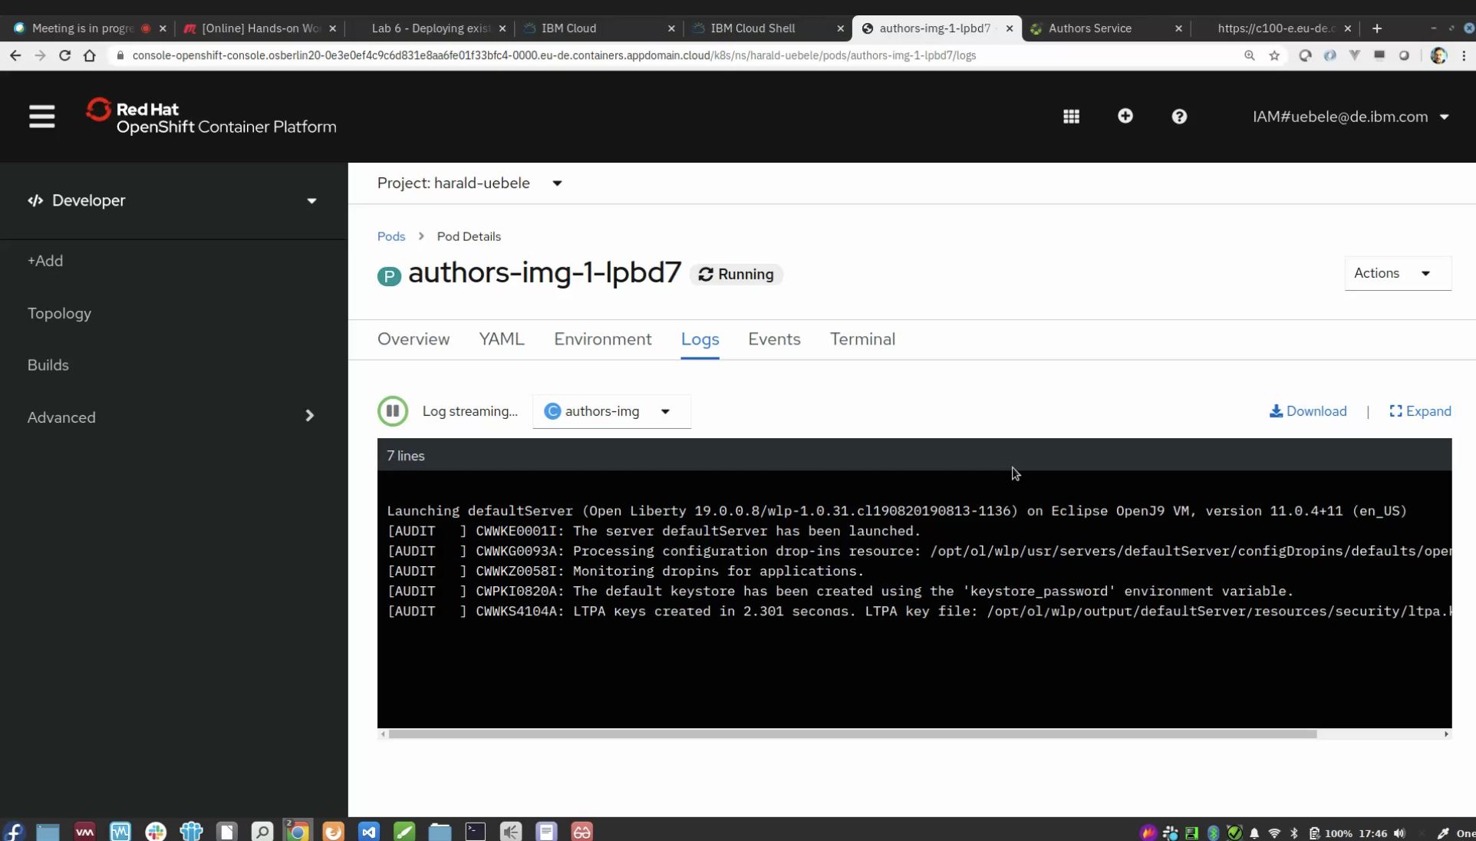

**Open logs finished, click omn the location link top open openliberty image (built)**

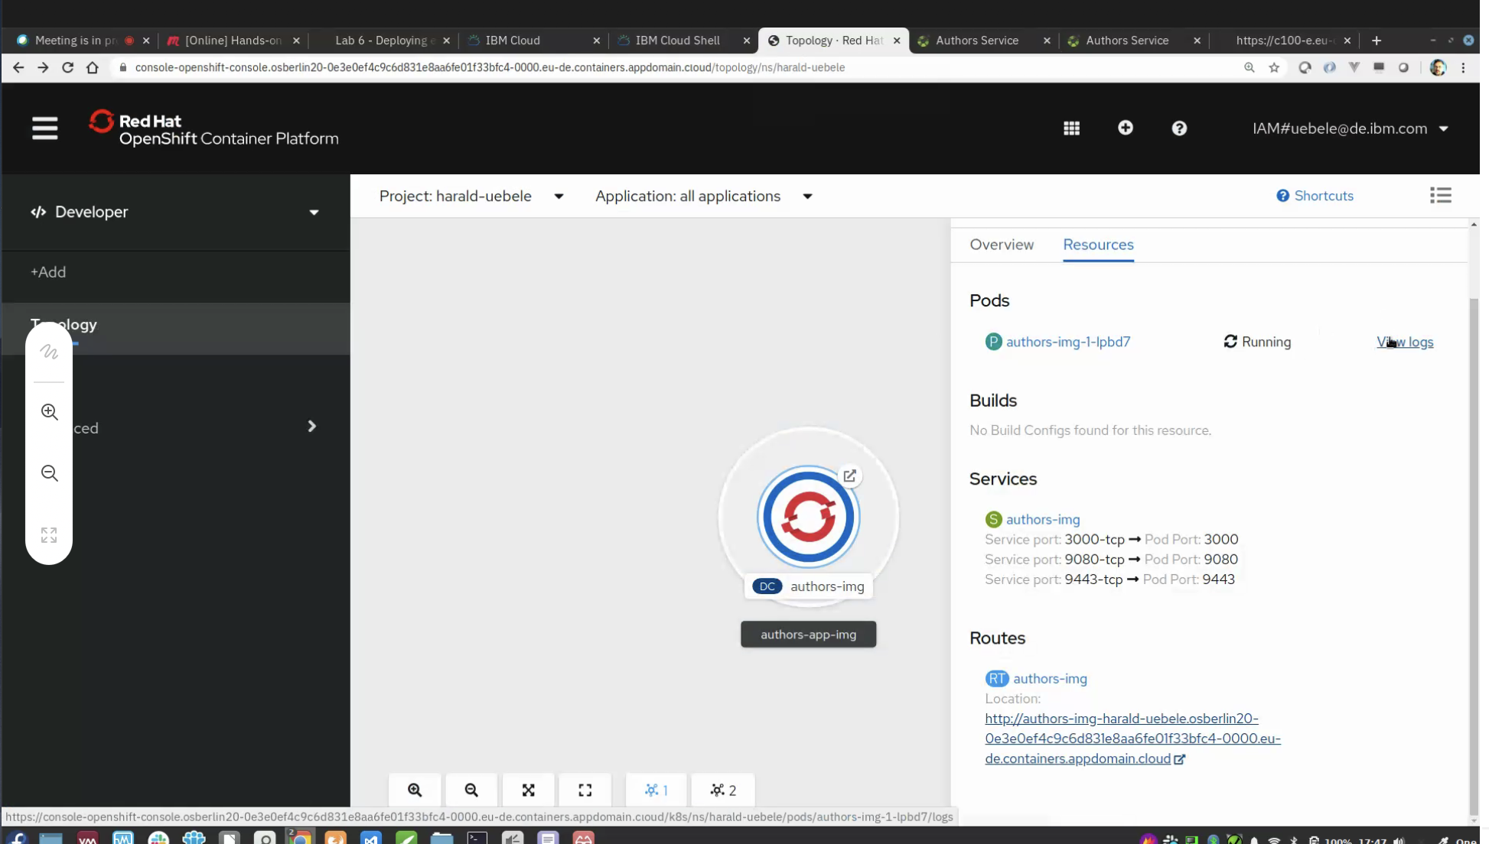

Then we can see the openliberty 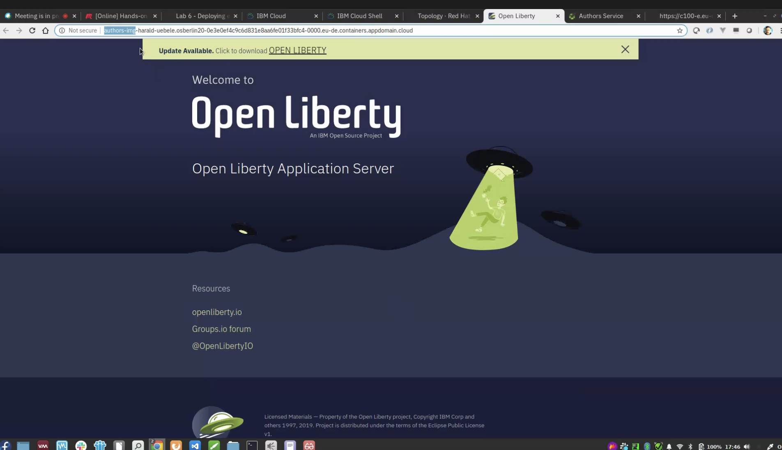

Add /openapi/ui to above openliberty link and then we can see swagger ui 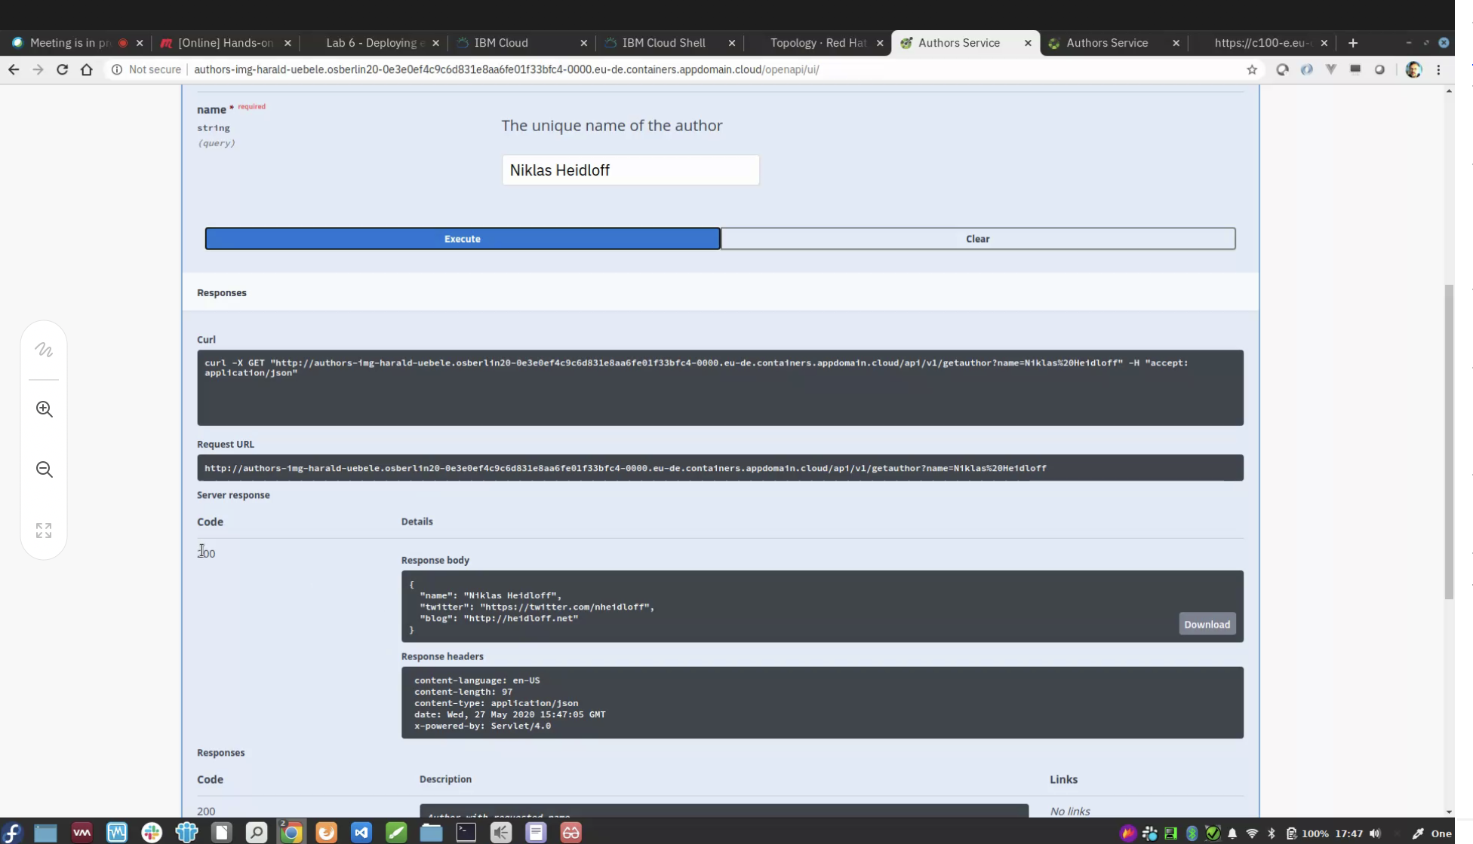

Pod shows the deployment images as shown below

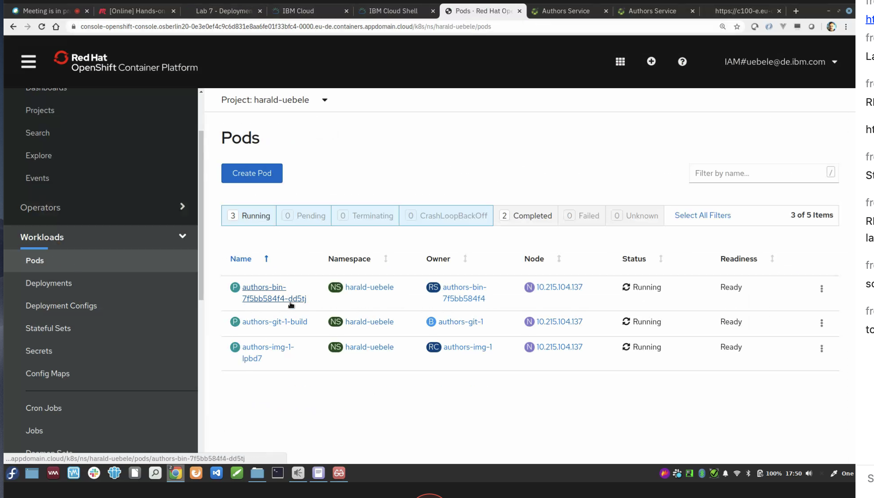

# Lab 3 - Deployments of Code in GitHub Repos

<https://ibm.github.io/openshift-on-ibm-cloud-workshops/7-github.html>

In developers view, we have all 3 deploymnets (build, docker, git)

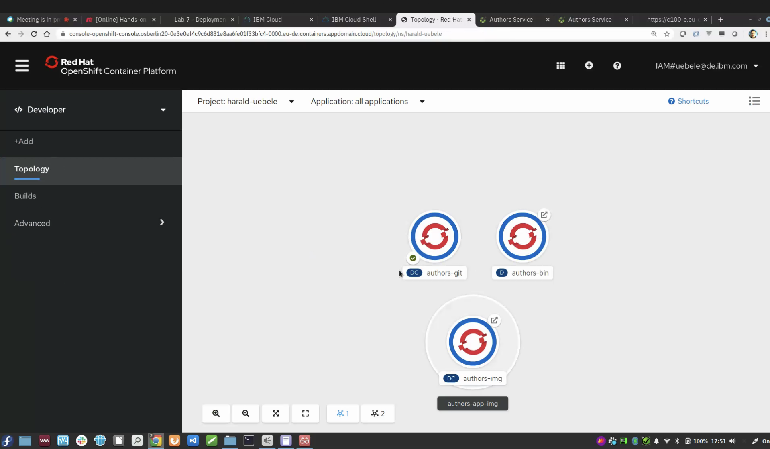

Lab 4 – Source to image(s2i) deployments (cloundfoundry..we don’t build container images..we push code to cloudfoundry & cloundfoundry creates running image for you)

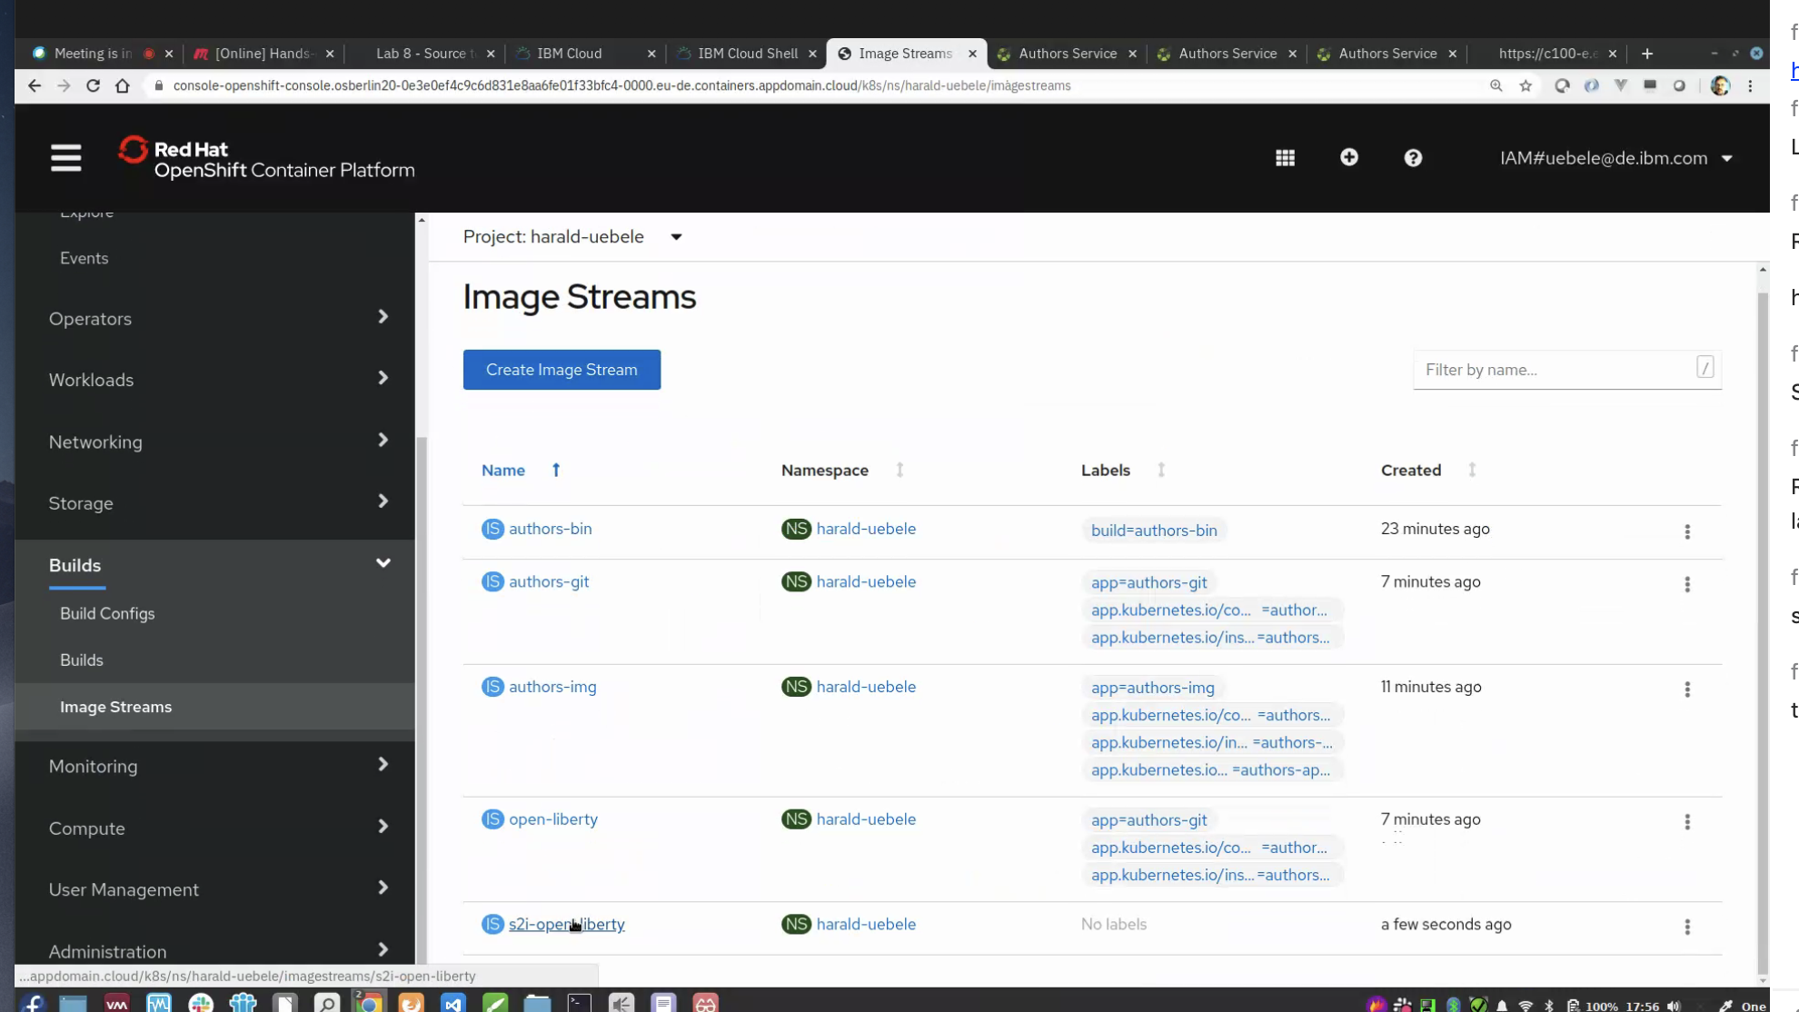

mvn package

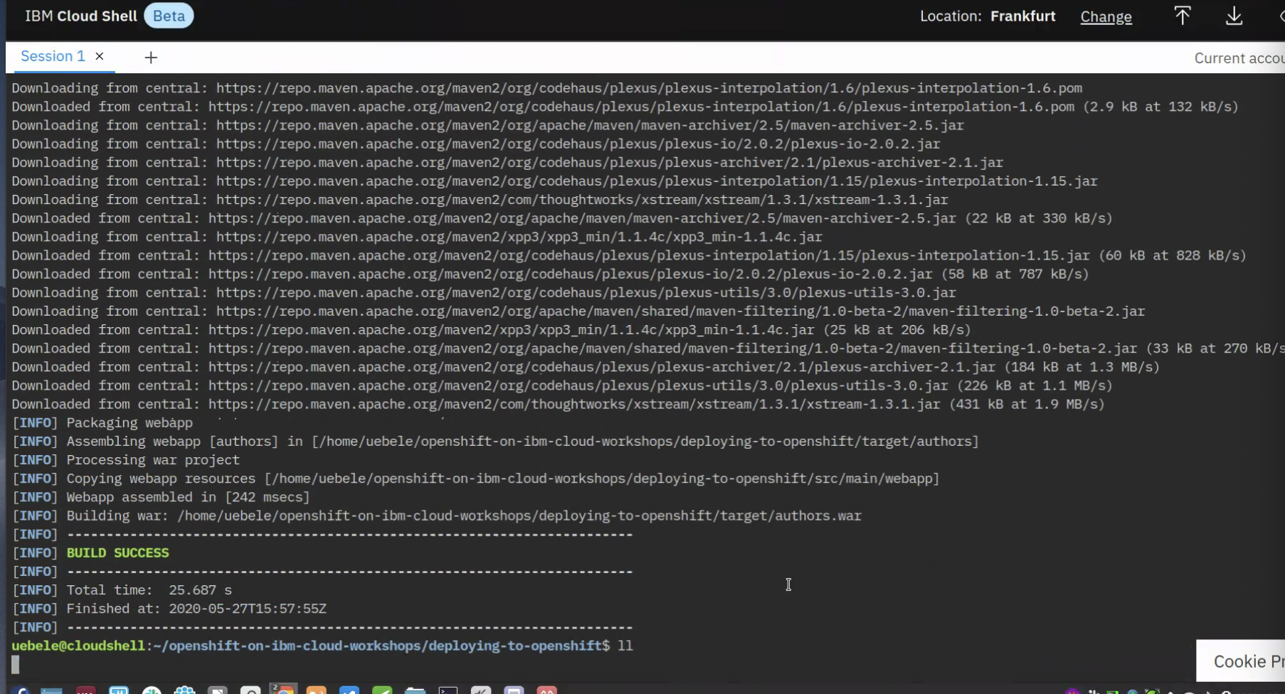

Compiled java code and created applications war file as shown below

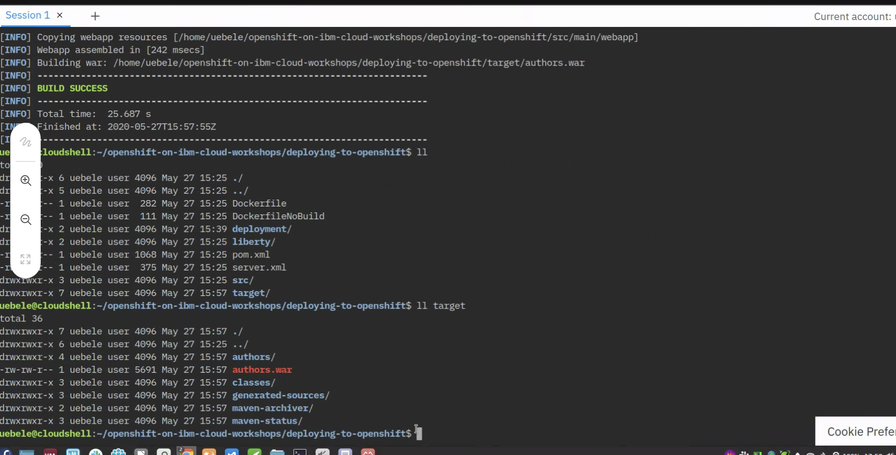

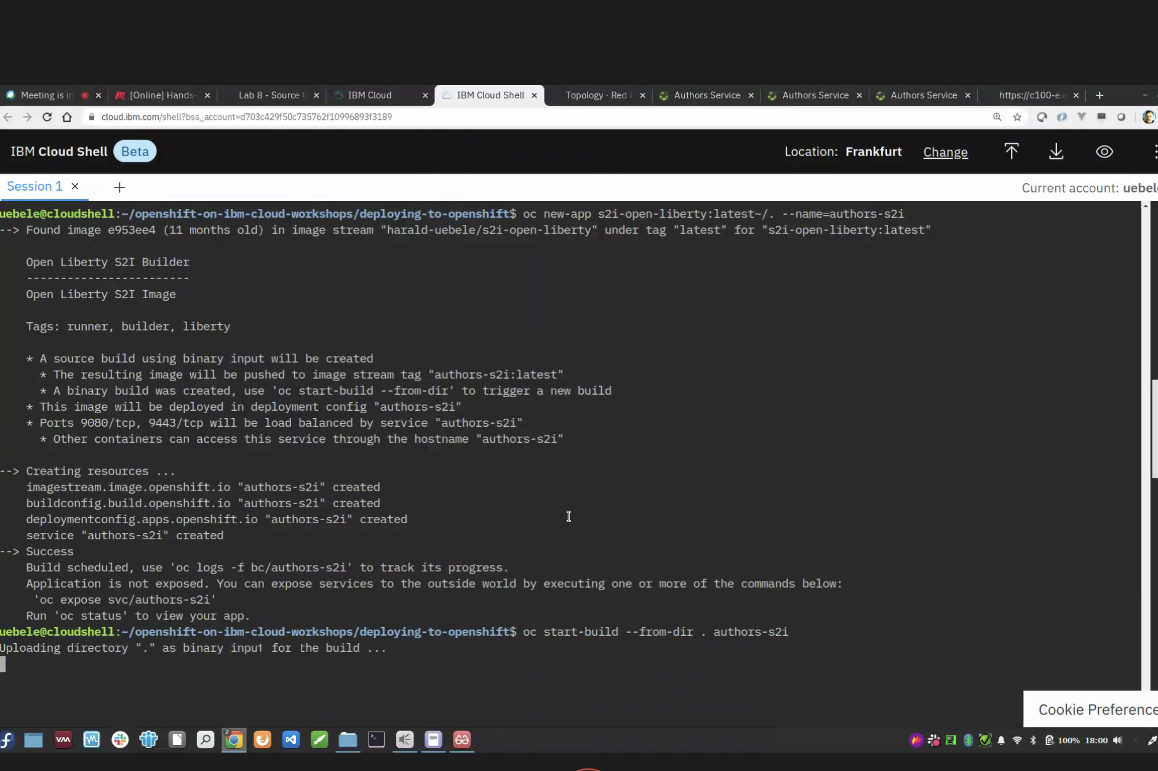

**Chk logs after build**

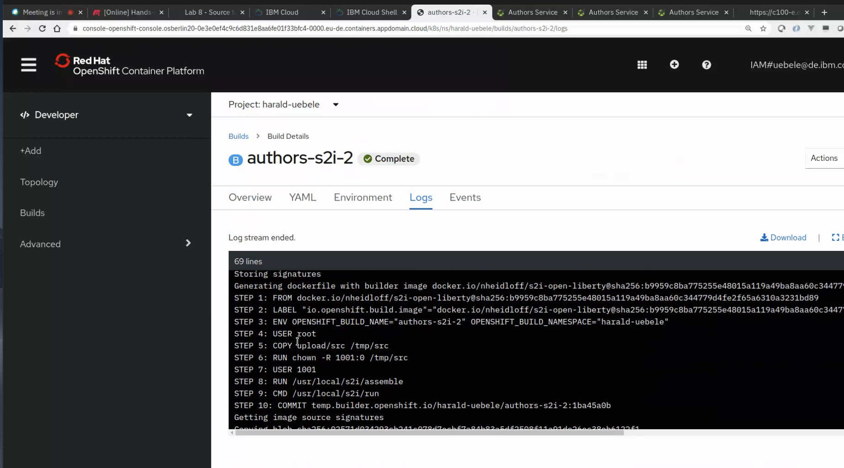

**Image push is successful as shown below (build2). We have now running pod.**

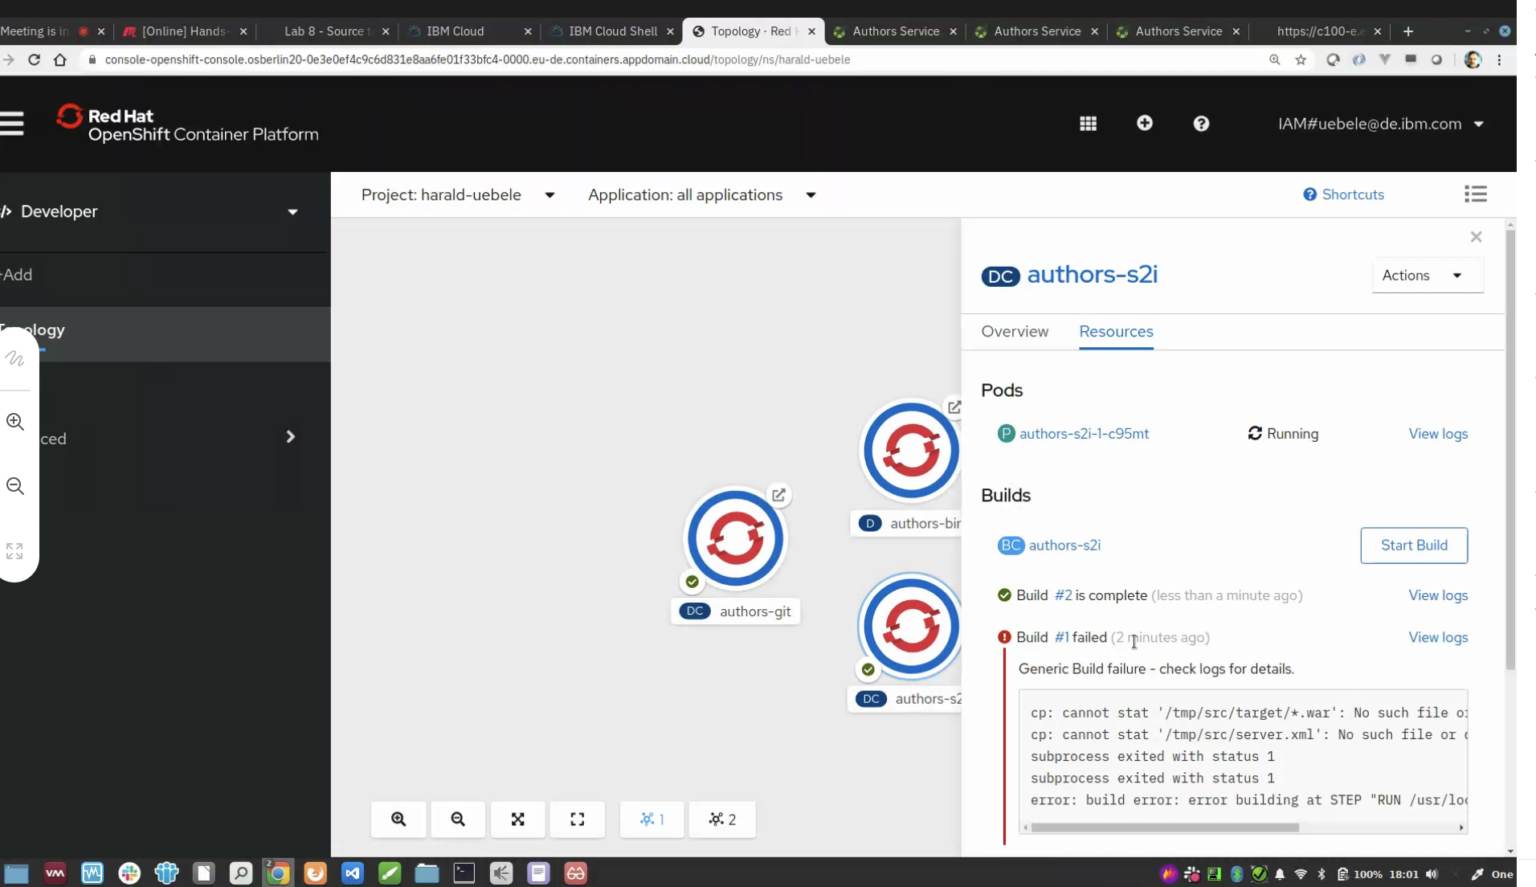

**Click on location** 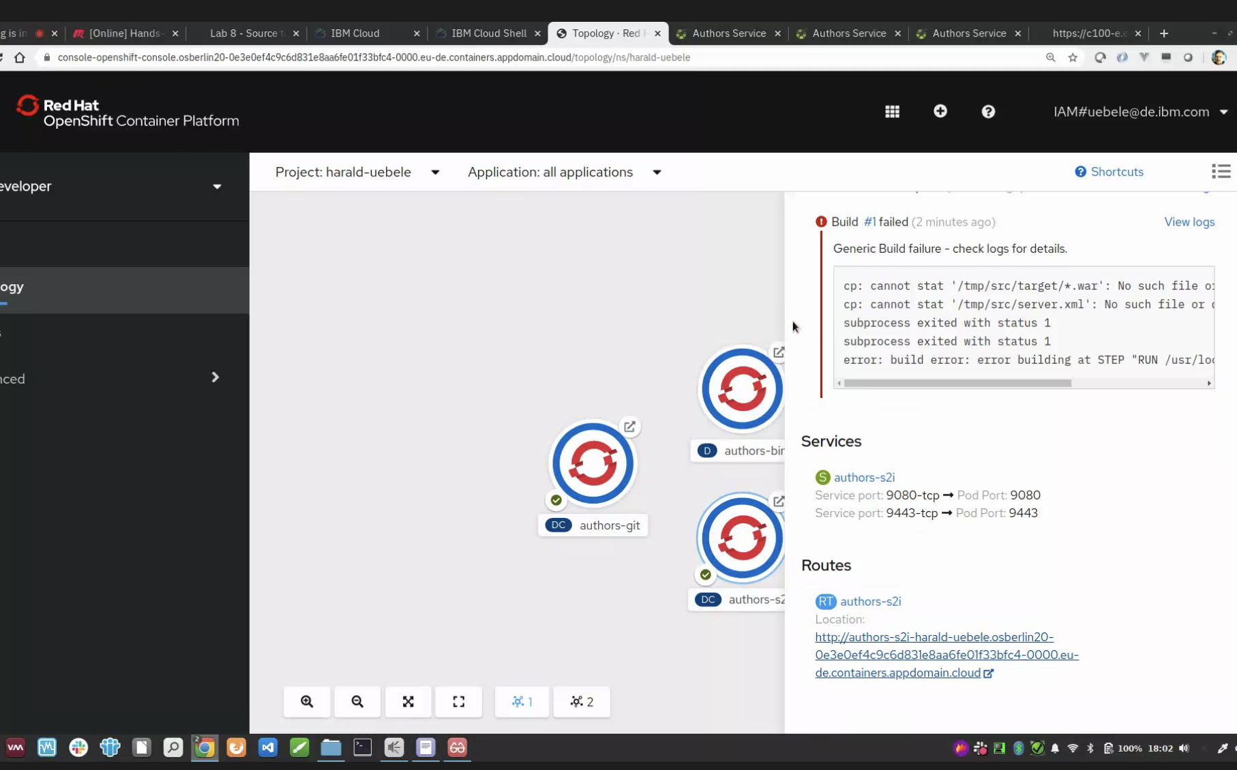

open the openliberty , swagger ui and do execute..u get 200 msg seccusful

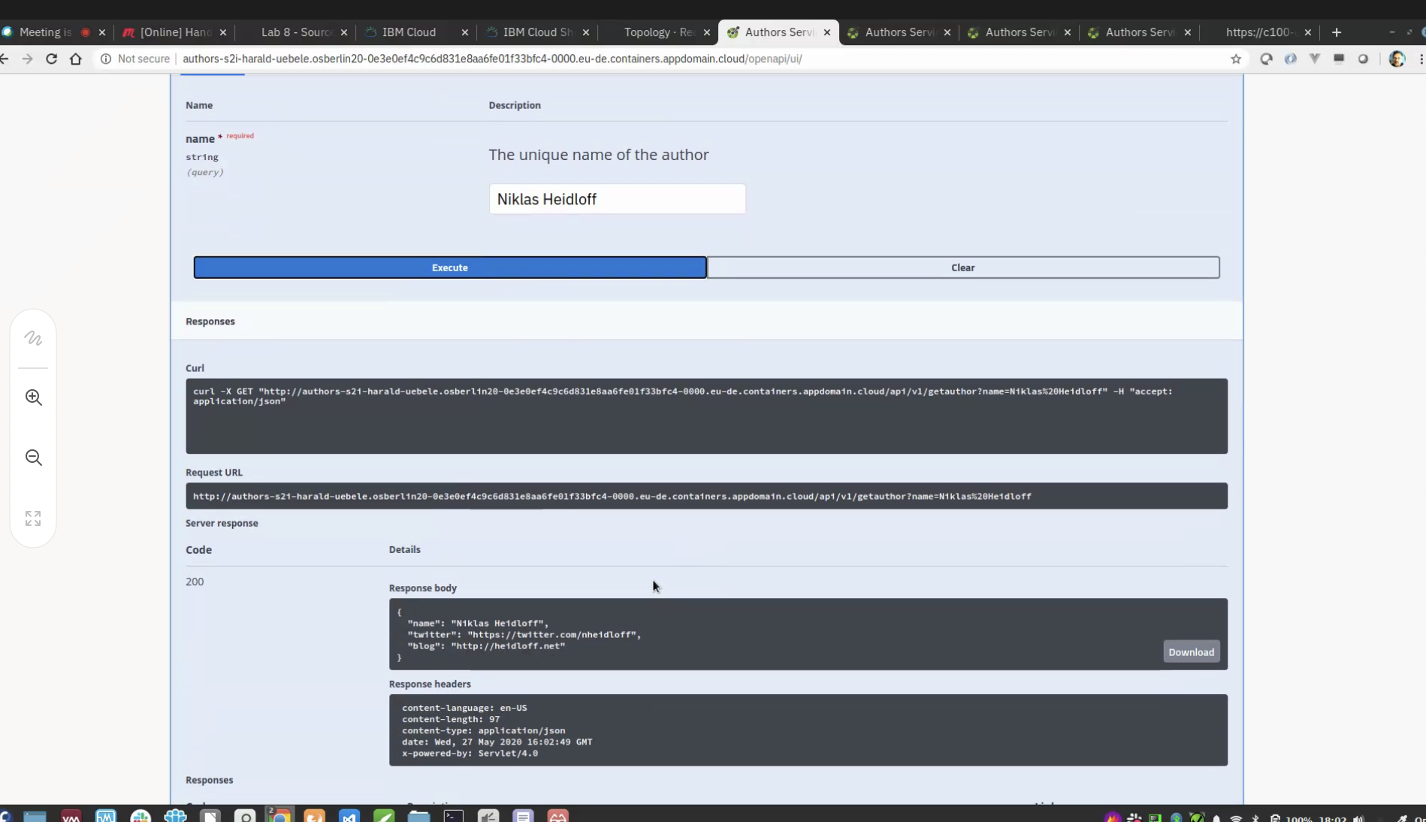

**4 labs finished. 4 pods below**

